**Macromolecules in Food: Names _____________________ (1pt) /100pts**

1. Use the selected four different cereal boxes. Write down the names of the cereals in the table: **(4pts)** /4

2. How do you choose your breakfast cereal? Taste? Nutrients? What your parents buy? Since you are becoming an expert in the field of macromolecules, let’s say that you are searching for a cereal that is most balanced in the major nutrients you need for health. **Based upon the cereals provided (without looking at the labels), which do you *think* is the most balanced cereal and the least balanced cereal and why? Enter your options in the table below “Hypothesis” (10pts)** /10

|  |  |  |  |  |
| --- | --- | --- | --- | --- |
|  | Cereal #1 | Cereal #2 | Cereal #3 | Cereal #4 |
| **Name** |  |  |  |  |
| Best/Worst |  |  |  |  |
| Why? |  |  |  |  |

3. On each box, find the section labeled “Nutrition Facts.” We will use this information to find out which cereal is the most balanced. **(1pt per row… 17pts total)**

a. For each cereal, record the **serving size in grams**.

|  |  |  |  |
| --- | --- | --- | --- |
| Cereal #1 | Cereal #2 | Cereal #3 | Cereal #4 |
|  |  |  |  |

b. Record the **number of calories** per serving of each cereal. (MAKE SURE YOU READ THE COLUMN LISTING THE INFORMATION FOR THE CEREAL ALONE, **NOT** THE CEREAL WITH MILK.) Calories tell how much energy is in the cereal.

|  |  |  |  |
| --- | --- | --- | --- |
| Cereal #1 | Cereal #2 | Cereal #3 | Cereal #4 |
|  |  |  |  |

c. Record **grams of total fat** per serving. Fat is stored by the body for energy but it’s also the major component of cell membranes.

|  |  |  |  |
| --- | --- | --- | --- |
| Cereal #1 | Cereal #2 | Cereal #3 | Cereal #4 |
|  |  |  |  |

d. Record the **milligrams of sodium** per serving. Too much sodium is linked to high blood pressure, strokes, and heart attacks.

|  |  |  |  |
| --- | --- | --- | --- |
| Cereal #1 | Cereal #2 | Cereal #3 | Cereal #4 |
|  |  |  |  |

e. There are different types of carbohydrates: **Sugar** is used for energy, but excess sugar not used is stored as fat and is associated with numerous health concerns. **Other Carbohydrates** (like starches) are also used for energy, but long-term. **Dietary fiber** helps to “keep you regular” by aiding in digestion. Fill in the chart below with the **grams of each**. (If Dietary Fiber is not listed, assume there are 0 grams.) (Other refers to the other sugars not categorized as “sugar” or “fiber”. They all have it though 1 doesn’t list it. Do the math.)

|  |  |  |  |  |
| --- | --- | --- | --- | --- |
| Total Carbohydrate | | Sugar | Dietary Fiber | Other Carbohydrate |
| #1 |  |  |  |  |
| #2 |  |  |  |  |
| #3 |  |  |  |  |
| #4 |  |  |  |  |

f. Protein is very important to your overall health. You don’t use the protein you consume as actual structure; rather you break down proteins into vital amino acids during digestion and absorb them into your cells. You recycle these broken down amino acids and reassemble them into human proteins – enzymes, immune system molecules, and as the major component of your muscles, among others. The amount of protein is listed in grams. Fill in the chart below with the **grams of each** per serving.

|  |  |  |  |
| --- | --- | --- | --- |
| Cereal #1 | Cereal #2 | Cereal #3 | Cereal #4 |
|  |  |  |  |

g. Vitamins are an important part of every diet. They help build other macromolecules and allow your body to absorb other key minerals for health. For example, vitamin D helps you absorb calcium. Without calcium you cannot form solid bones. On food labels they are listed according to what percentage of your daily needed amount is in the food. Fill in the table with the **percentages of the vitamins** listed. (If a certain vitamin is not listed, assume that 0% is in the food.)

|  |  |  |  |  |  |  |  |
| --- | --- | --- | --- | --- | --- | --- | --- |
| Vitamin A | | B6 | C | D | Niacin | Thiamin | Riboflavin |
| #1 |  |  |  |  |  |  |  |
| #2 |  |  |  |  |  |  |  |
| #3 |  |  |  |  |  |  |  |
| #4 |  |  |  |  |  |  |  |

h. Minerals are needed to help the body to work properly, especially in your muscular and nervous systems. They are also listed by percentages. Fill in the table with the **percentages of minerals** listed.

|  |  |  |  |  |  |  |
| --- | --- | --- | --- | --- | --- | --- |
| Calcium | | Iron | Phosphorus | Magnesium | Zinc | Copper |
| #1 |  |  |  |  |  |  |
| #2 |  |  |  |  |  |  |
| #3 |  |  |  |  |  |  |
| #4 |  |  |  |  |  |  |

/17

4. Based upon what you have collected, create circle graphs illustrating the balance of the contents of each cereal. In your circle graph make a slice for fat, total carbohydrates, protein, and other contents. “Balanced” for this lab means… “Trainers and doctors recommend that if you are using a light exercise routine you should break down your total daily calories something like this”:

 50% carbs

http://thescienceofeating.com/food-combining-how-it-works/calories-fat-carbs-protein-per-day/

25% protein

25% fat

(complete the circle graph. 5pts)

Graph below:

8pts per graph

4pts = appropriate pie

4pts = labeled correctly

#1 #2

#3 #4

/37pts

5. Now, answer the analysis questions.

**Analysis Questions:**

1. For the following questions. Mark “☺” in the column for the cereal that shows the **best option**. Mark “☹” for the cereal that shows the **worst option**. **(1pt per)**

|  |  |  |  |  |
| --- | --- | --- | --- | --- |
|  | Cheerios | Frosted Mini Wheats | Luck Charms | Raisin Bran |
| Based on the recommendation that most of us need very little Fat, which cereal, based upon the labels, would you say is: |  |  |  |  |
| Sodium should be monitored. Which is: |  |  |  |  |
| Based on the recommendation that you need carbohydrates, but should avoid excess sugar; which cereal would you classify as: |  |  |  |  |
| Based on the fact that you need protein, which cereal would you classify as: |  |  |  |  |
| Looking at the vitamins listed, which cereal overall gives you: |  |  |  |  |
| Looking at the minerals listed, which cereal overall gives you: |  |  |  |  |
| Confirm or reject your hypothesis”: Looking at all of the data that you gathered in this lab, which cereal would you classify as:  [Hint: Look at the column with the most ☺ and least ☹.] **(5pts)** |  |  |  |  |

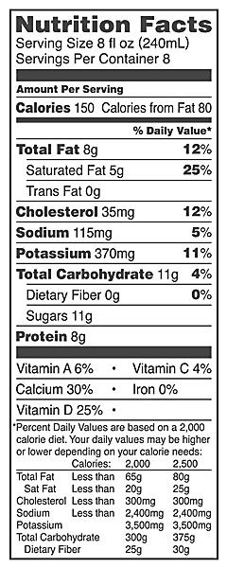

2. (5pts) Are these cereals as sources of macronutrients “balanced”? & Why do you think this?

3. (5pts) To the left is a nutrition label for Simple Truth Organic Whole Milk. Most people put milk in their cereal, but what is this adding, other than flavor and texture? How does adding milk to your cereal affect your “balance” in general, with regard to the 3 major macromolecule classes analyzed?

4. (5pts) What does this say about a diet that includes cereal as a source of macronutrients? How should you *supplement* the rest of your diet (what should you add to your diet) to be healthy and balanced? Give an example.

5. (5pts) A huge issue in food is marketing. You are sold things as being “healthy” and part of a balanced diet even though the packaging might be misleading. Look at the covers for the cereals. What are two things advertisers do to the packaging to try and advertise themselves as a “healthy” food?

/31

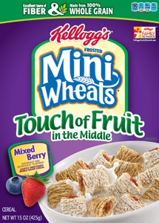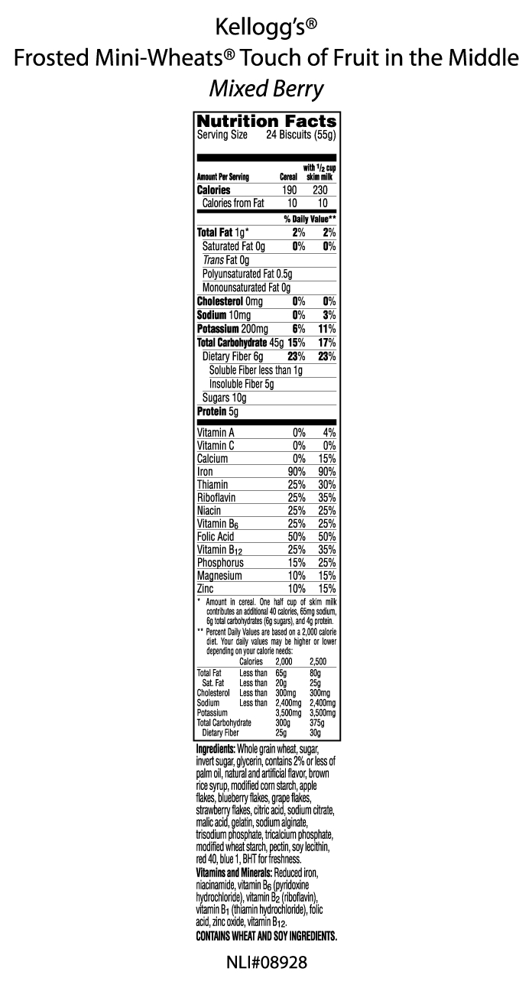

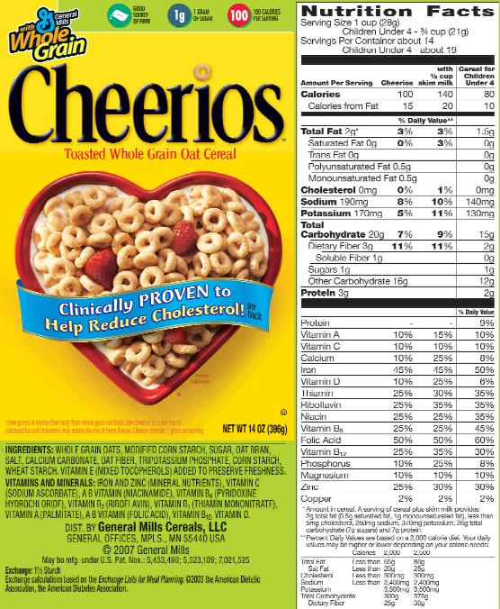

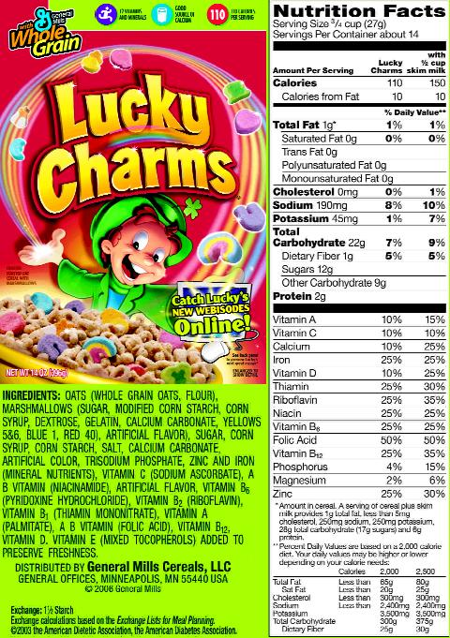

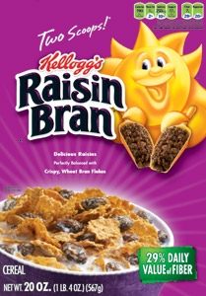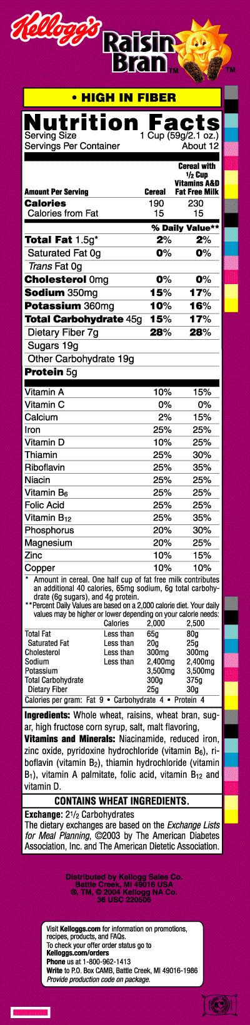



% = PART

WHOLE

The “WHOLE”

This is the total grams per serving,

%FAT(Part) = 1.5g x 100 = %fat

59g

%CARBS = 45g

59g

%Protein = 5g

59g